**Analysis Conclusions**

The final KNIME workflow is shown below:

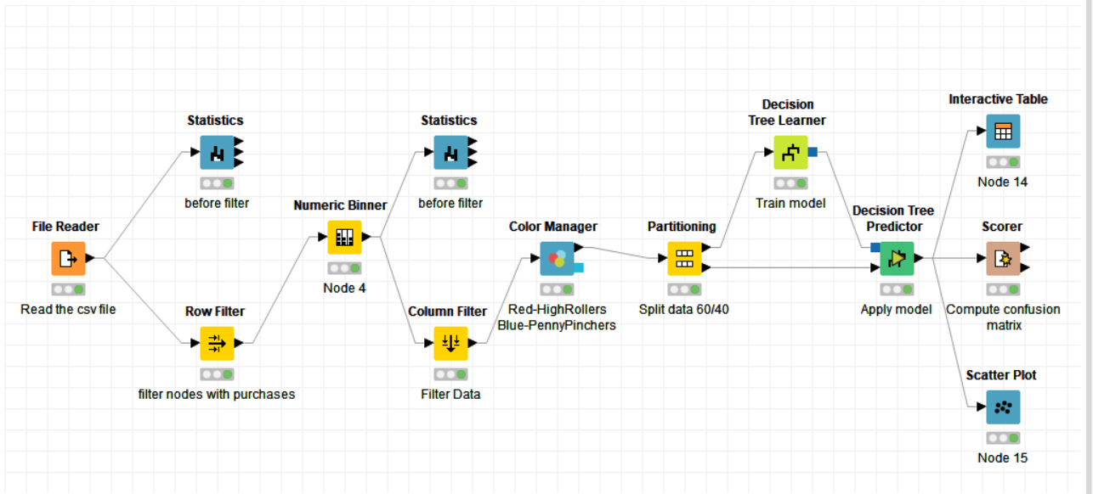

What makes a HighRoller vs. a PennyPincher?

Based on the Decision Tree that was formulated, it can be concluded that players using iOS devices has been classified as HighRollers, while Players of other platforms have been classified as PennyPinchers.

Linux being the first in terms of PennyPinchers (97% users) and just 3% highrollers

Mac being the second in terms of HighRollers (37% users).

Android on third with 13.5% highRollers and 86.5% PennyPinchers.

|  |
| --- |
| **Specific Recommendations to Increase Revenue** |
| 1. We should be Targeting the iOS users more than other platform users. A separate budget should be kept for promotion of the game on iOS platform so that the user base will increase and so does the revenue as iOS users being the HighRollers. |
| 2. Encouraging them(iOS players) by providing rewards to write the good review of the game, so that other platform users can be influenced by the rating and reviews of the iOS platform. Thus increasing the Downloads and the user Base |
| 3. Providing Special Discount to the Other platform users to increase the tendency of the user to make the purchase. |
| 4. The most popular and frequently used item should be priced so that the users will be forced to make the purchase in order to play the game with ease.  This method is not ideal as it will lead the players to uninstall the game. So this could be a way but not the best way |